**CE101 Engineering Drawing July- Nov 2019**

**Indian Institute of Technology Guwahati**

**Lab Sheet-1 Lettering, Dimensions and Scales Tuesday Morning**

**Max Marks: 90 + 10 (overall neatness) Date: 06.08.2019**

1. Prepare your drawing sheet by using 20 mm left hand margin, and 10 mm for the top, bottom and right hand side margins. **[5]**

Complete the title block (65 mm x 160 mm, as shown) at the right bottom corner of your drawing sheet. The dimensions are for reference, and need not be marked for the title block. **[20]**

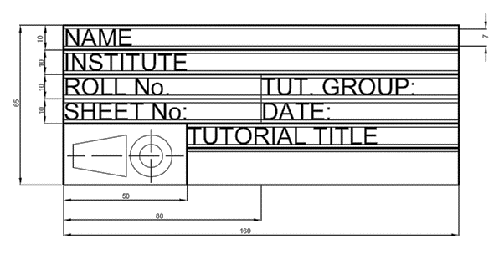

1. Write freehand the following sentence using single stroke vertical letters. The capital letters should be of height 7 mm. Follow the specifications of A-Type lettering for the other alphabets. **[15]**

**The Quick Brown Fox jumped   
over a Lazy Dog**

1. Draw a diagonal scale of RF = 3/100, showing meters, decimeters and centimeters. The longest distance to be measured is 5 m. Show a length of 3.69 m on the scale. **[15]**
2. The following have several marked and unmarked mistakes in dimensioning. Reproduce the object and properly dimension the same. Follow the unidirectional system of dimensioning. **[20]**

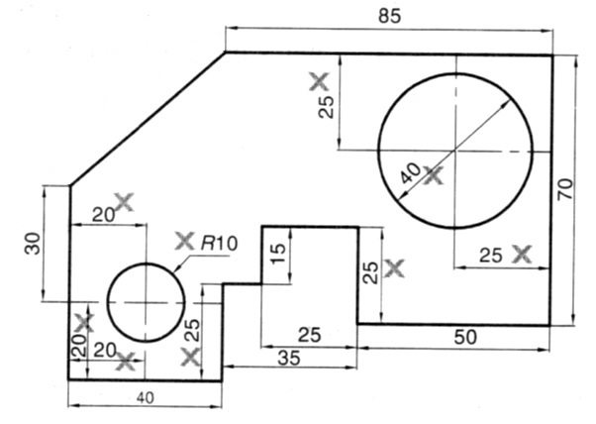

1. Construct a forward Vernier scale to read meters, decimeters and centimeters. The scale should be long enough to measure 3 m. Mark a distance of 1.82 m on the scale. **[15]**